Image | Title | notes
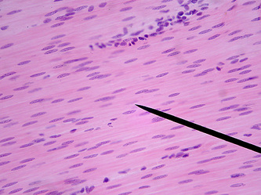 | Smooth muscle | Don’t confuse with dense regular ct or skeletal muscle | Rank hardness, difficulty
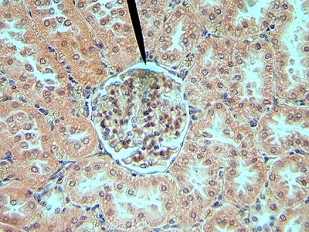 | Kidney tissue with pointer at nephron corpuscle (glomerulus, glomerular capsule/Bowman’s) | Can see proximal and distal convoluted tubules
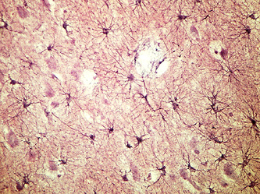 | Nervous tissue | Star-like neurons. Rest are glial cells (neuroglia)
 | Not me

